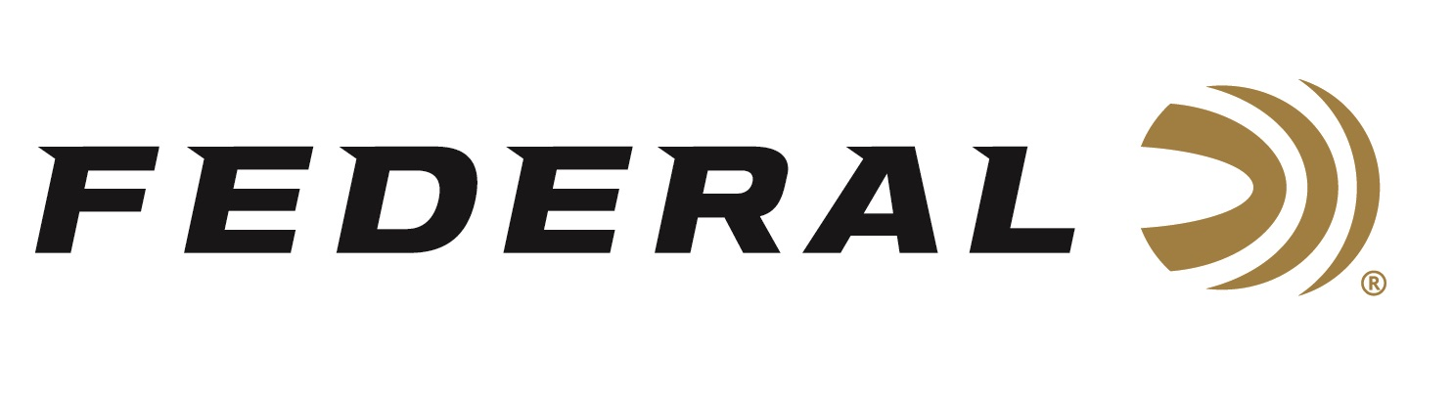

FOR IMMEDIATE RELEASE

It’s a “Wild Ride” On This Episode of the “It’s Federal Season” Podcast

ANOKA, Minnesota – September 17, 2020 – Joining the “It’s Federal Season” podcast is Nick Hoffman, host of Nick’s Wild Ride on Outdoor Channel. Nick has traveled the globe, either playing his fiddle with country music stars, his own band or as a solo star as well as hunting the world’s diverse quarry. How has he combined his passions into careers many only dream of? Find out all the twists and turns of Nick’s amazing story from humble beginnings growing up in rural Minnesota to stardom in Nashville on this crazy half hour ride.

Episode No. 12 - Going to be a Wild Ride
https://www.federalpremium.com/podcast.html

“Nick has such a unique story with the Federal family,” says Federal Ammunition’s Vice President of Marketing Jason Nash. “Nick literally grew up in the shadows of the factory of Federal Ammunition in Anoka, MN. His family has a connection with Federal that goes back long before he was born and it’s really cool to tie the historical circle back together with a sponsorship of his popular television show,” says Nash. Hoffman details his relationship with Federal Ammunition, his path to country music stardom, and the influencers in his music career and hunting lifestyle show on the popular Outdoor Channel network.

In the Tech Talk segment, Federal has a long history of loading Premium bullets for hunters pursuing their dream animal, which could be that 6 ½ year-old buck that’s been calling the ‘back forty’ home for years. Director of Product Development Jared Kutney weighs in on bullet construction and all the attributes that make Federal’s new Terminal Ascent the go to bullet on the market today. Kutney gives his recommendations and an informative review on many popular bullets and the game they are best suited for that makes this segment a must listen to before seasons open this fall.

Before signing off, find out what promotions are available for consumers to buy Federal products and merchandise. Look for more podcasts at www.federalpremium.com or where you find your favorite podcasts.

Federal ammunition can be found at dealers nationwide or purchased online direct from Federal. For more information on all products from Federal or to shop online, visit www.federalpremium.com.
Press Release Contact: JJ Reich
Senior Manager – Press Relations
E-mail: VistaPressroom@VistaOutdoor.com

About Federal Ammunition
Federal, headquartered in Anoka, MN, is a brand of Vista Outdoor Inc., an outdoor sports and recreation company. From humble beginnings nestled among the lakes and woods of Minnesota, Federal Ammunition has evolved into one of the world's largest producers of sporting ammunition. Beginning in 1922, founding president, Charles L. Horn, paved the way for our success. Today, Federal carries on Horn's vision for quality products and service with the next generation of outdoorsmen and women. We maintain our position as experts in the science of ammunition production. Every day we manufacture products to enhance our customers' shooting experience while partnering with the conservation organizations that protect and support our outdoor heritage. We offer thousands of options in our Federal Premium and Federal® lines-it's what makes us the most complete ammunition company in the business and provides our customers with a choice no matter their pursuit.

